Docker file for sample Python application.

# Build a Docker image

Code:

Docker build -t my-python-app .

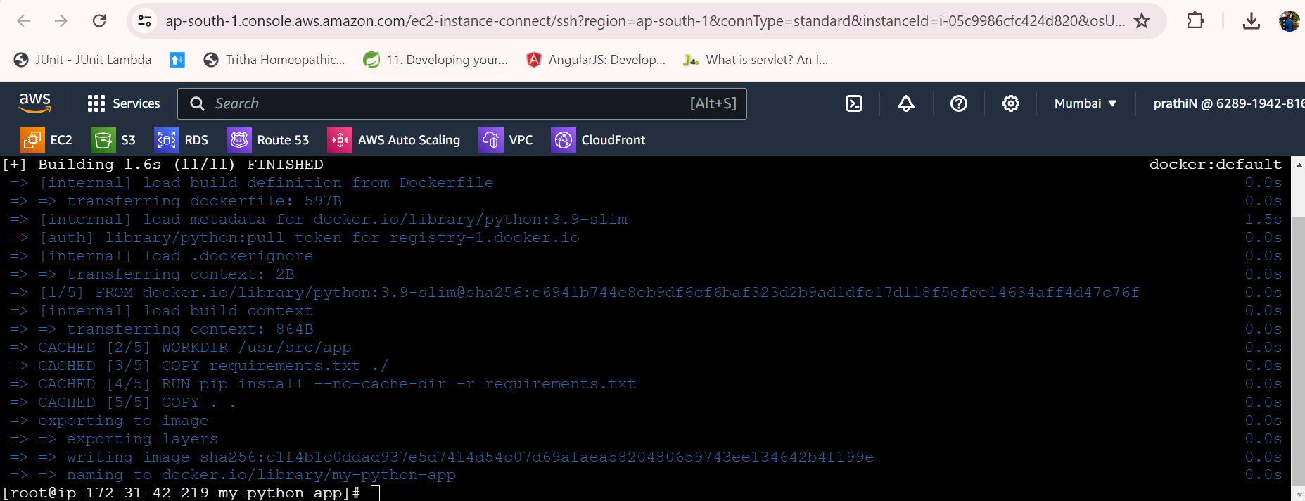

# Run the Docker container

Code:

docker run -p 4000:80 my-python-app .

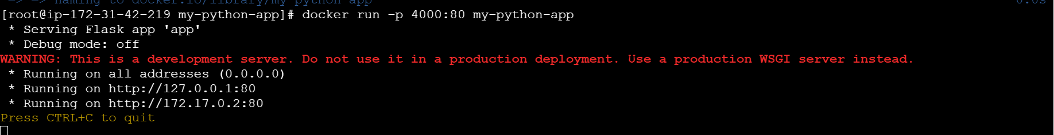

# OutPut

